Luis Cervantes Oropeza

CS333 Project 4

3/7/2021

**Test name:** With CS333 PROJECT set to 0 in the MakeFile

**Test Description:** Compiles correctly with the CS333 P4 macro turned off, when CS333 PROJECT is set to 0 in the Makefile.

**Expected results:** Expected results is for this to pass.

**Test Output / Actual Results:**

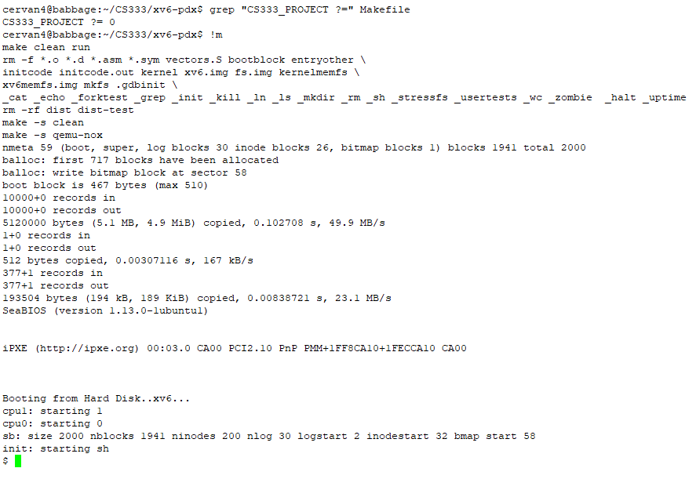

**Discussion:** The results were as expected everything compiled and worked properly

**Indication of Pass/Fail:** This test Passed

**Test name:** For MAXPRIO = 0

**Test Description:**

* Show that the scheduler operates as a single round robin queue, as it did in project 3,
* Show that setpriority() for any value other than 0 fails.
* Code should not attempt promotion or demotion when MAXPRIO == 0.

**Expected results:** I expect for all of the results to pass and for it to do everything correct when MAXPRIO is set to 0

**Test Output / Actual Results:**

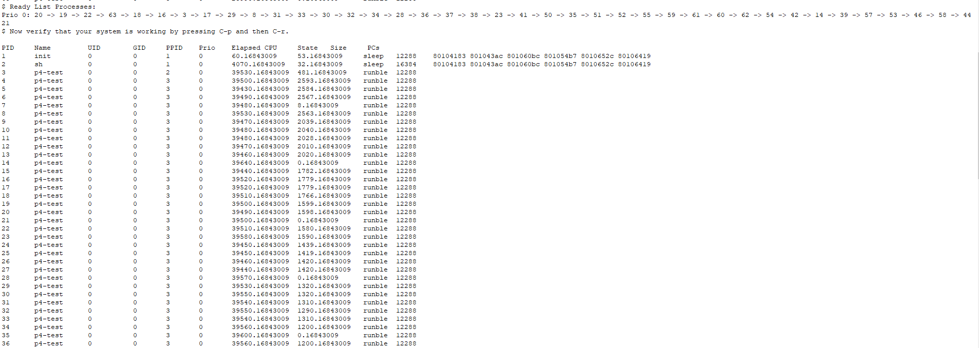

Code should not attempt promotion or demotion when MAXPRIO == 0:



**Discussion:** All of the tests passed as expected and would not promote or demotion when maxprio was set to 0.

**Indication of Pass/Fail:** This test Passed

**Test name:** For MAXPRIO = 2

**Test Description:**

* Show that the scheduler always selects the first process on the highest priority non-empty list
* Show that promotion correctly moves processes on the ready lists to the next higher priority list (if one exists) and maintains correct ordering
* Show that demotion correctly moves a process to the next lower priority list (if one exists) when the processes budget is used up

**Expected results:** I expect for all of the results to pass and for it to do everything correct when MAXPRIO is set to 2

**Test Output / Actual Results:**

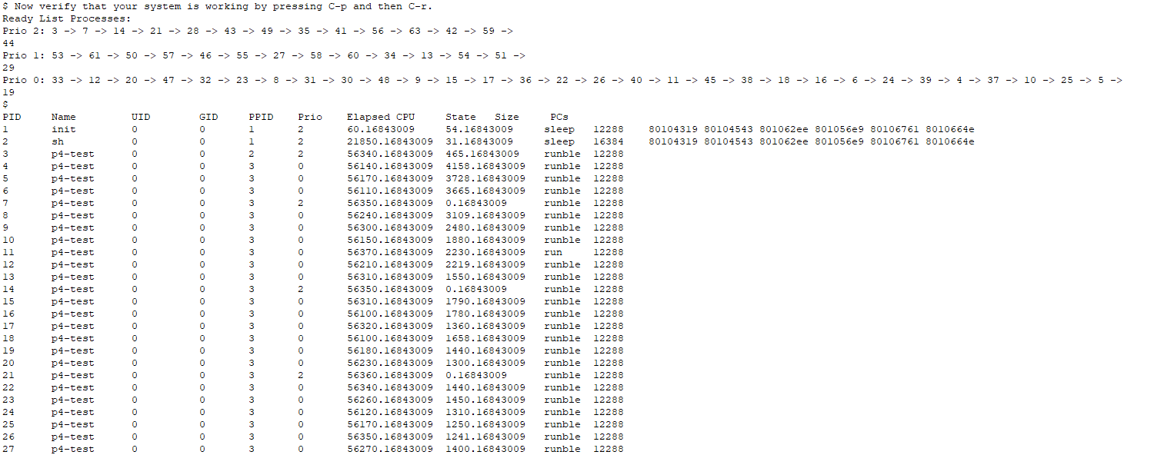

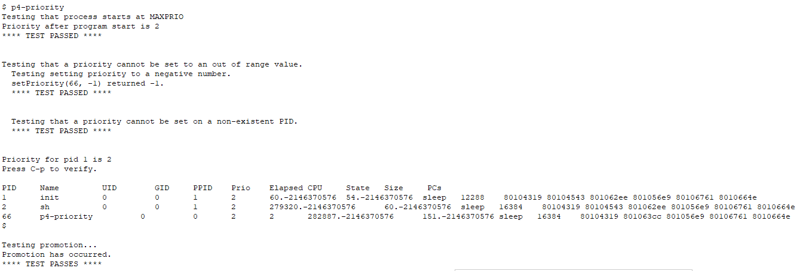

**Discussion:** All of the tests passed as expected and promote and demotion worked properly and all of the tests passes with the correct values

**Indication of Pass/Fail:** This test Passed

**Test name:** For MAXPRIO = 6

**Test Description:**

* Show that the scheduler always selects the first process on the highest priority non-empty list
* Show that promotion correctly moves processes on the ready lists to the next higher priority list (if one exists) and maintains correct ordering
* Show that demotion correctly moves a process to the next lower priority list (if one exists) when the processes budget is used up

**Expected results:** I expect for all of the results to pass and for it to do everything correct when MAXPRIO is set to 2

**Test Output / Actual Results:**

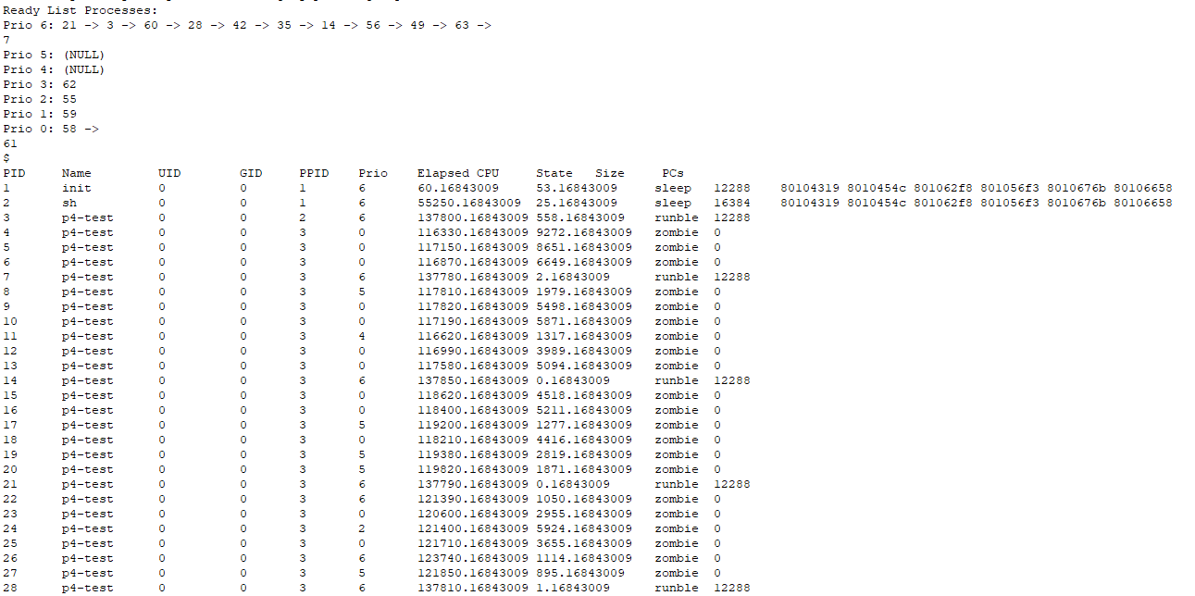

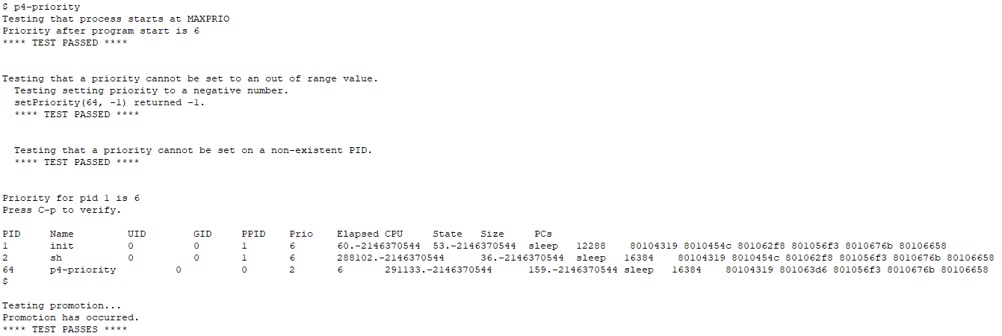

**Discussion:** All of the tests passed as expected and promote and demotion worked properly and all of the tests passes with the correct values

**Indication of Pass/Fail:** This test Passed

**Test name:** setpriority(), getpriority()

**Test Description:**

* Show that the priority is changed and budget reset when given a valid PID and priority
* Show that changing the priority of a process on a ready list correctly moves the processto the list corresponding to the new priority
* Show that setting the priority of a process on a ready list to the same priority it alreadyhas does not change the position in the list for that process
* Show that calling setpriority() with an invalid PID and/or priority returns a rele-vant error code and leaves the process priority and budget unmodified.
* Returns -1 if PID is not found or process is in the UNUSED state.
* Shows the correct priority for any process other than the current process

**Expected results:** Expect it to pass all of the results and for it to be able to get and set properly and for the priority to be correct.

**Test Output / Actual Results:**

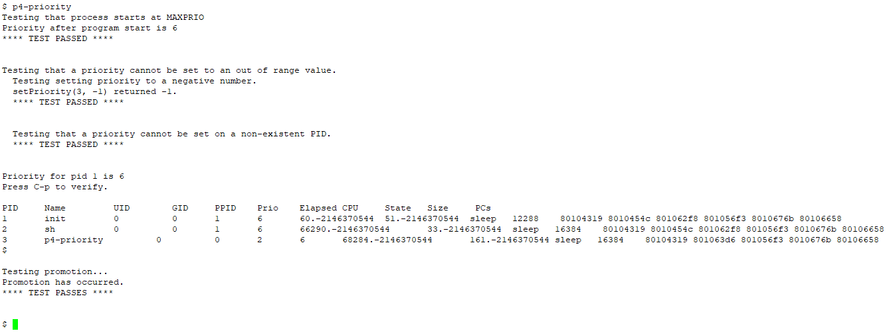

**Discussion:** All of the tests passed as expected the set and get worked as they were supposed to which shows that everything was working properly.

**Indication of Pass/Fail:** This test Passed

**Test name:** Updated Commands

**Test Description:**

* Show that ps correctly displays the process priority
* Show that control - p correctly displays the process priority
* Show that control -r correctly displays all ready lists, from highest to lowest priority,and the budget for each process

**Expected results:** For all of the test to pass and display in the right format except for the ps command

**Test Output / Actual Results:**

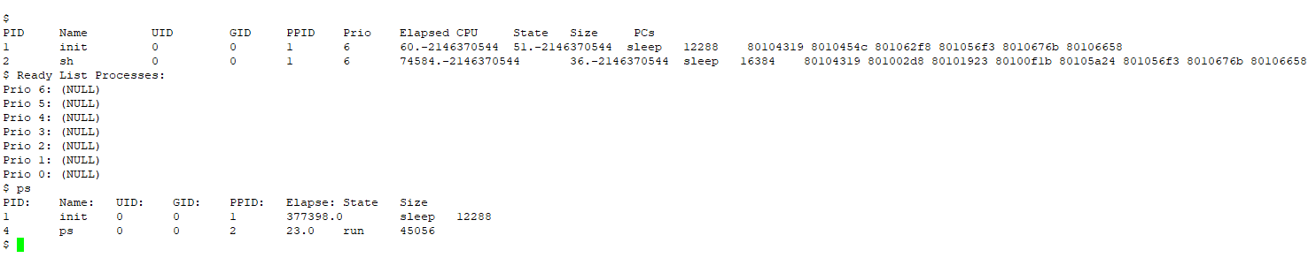

**Discussion:** All of the tests passed however ps didn’t pass since there was no priority since I couldn’t find the ps command to add priority

**Indication of Pass/Fail:** This test Passed